AI Skills in UK Job Listings
Study Data & Findings
March 2026
Analysis of 1,019 non-technical UK job listings sourced from LinkedIn

1. Headline Numbers
Total job listings analysed: 1,019
Job listings referencing AI skills, tools, or terminology: 83 (8.1%)
Job listings referencing traditional software tools: 620 (60.8%)
Ratio of traditional tool mentions to AI mentions: 7.5 : 1
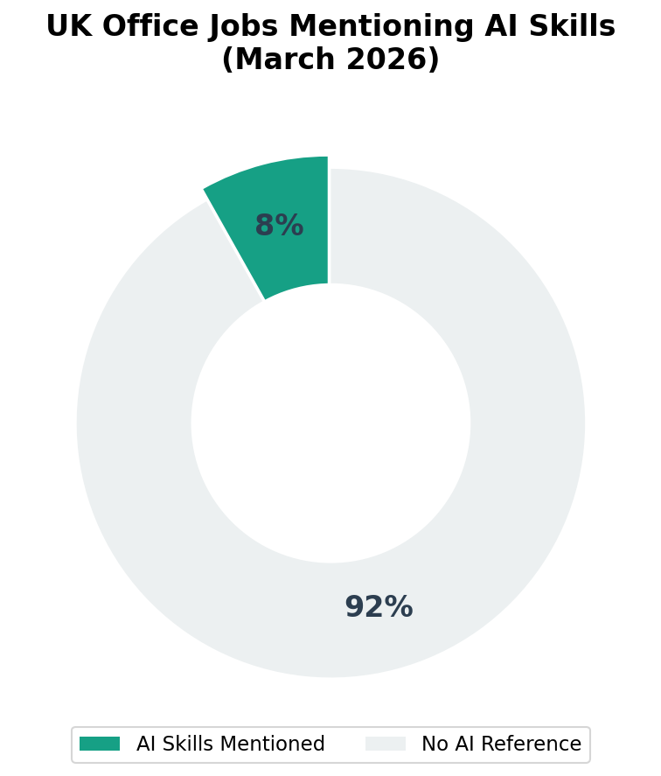

2. AI Requirement Levels
Of the 83 listings that reference AI, the level of requirement was classified as follows:
Level | Count | % of All Jobs
Required | 26 | 2.6%
Preferred | 7 | 0.7%
Mentioned only | 50 | 4.9%
No AI reference | 936 | 91.9%
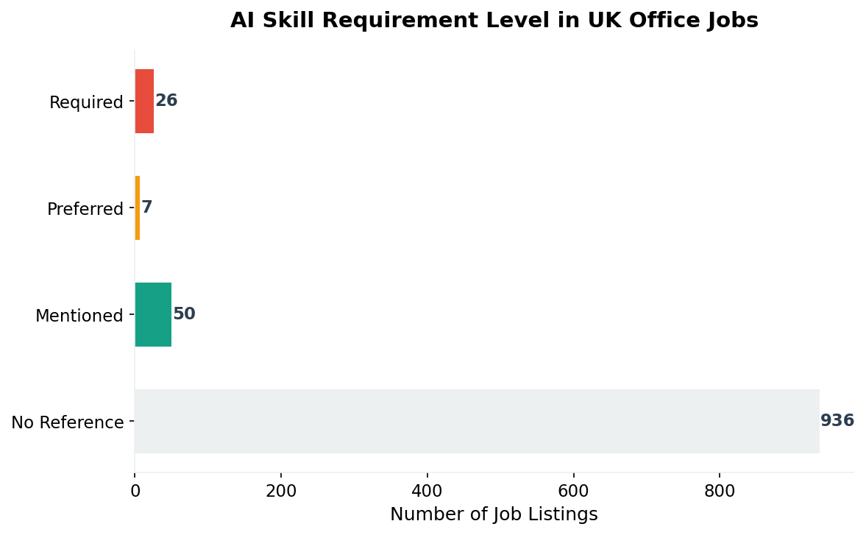

3. Findings by Role Category
Each job was classified into a role category based on its title. The “Other” category (549 jobs) contains roles that did not match the primary classification keywords and is excluded from the table below for clarity. Within “Other”, 53 jobs (9.7%) referenced AI.
Role Category | Total Jobs | AI Mentions | AI %
Customer Service | 10 | 2 | 20%
Marketing | 25 | 4 | 16%
Office & Admin | 50 | 4 | 8%
HR & Recruitment | 46 | 3 | 6.5%
Sales & Business Dev | 79 | 5 | 6.3%
Finance & Accounting | 138 | 8 | 5.8%
Legal & Procurement | 56 | 2 | 3.6%
Project & Operations | 66 | 2 | 3%
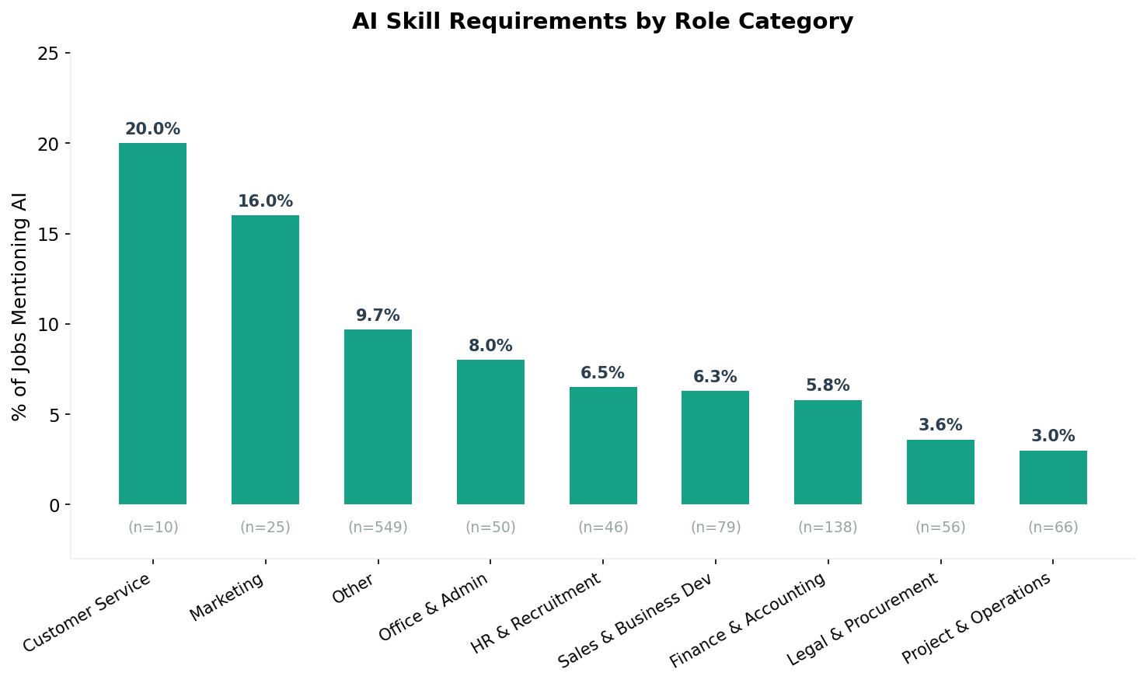

4. Findings by Seniority Level
Seniority levels are as classified by LinkedIn. Categories with fewer than 10 listings are excluded.
Seniority Level | Total Jobs | AI Mentions | AI %
Not Applicable | 193 | 29 | 15%
Director | 20 | 2 | 10%
Entry level | 271 | 21 | 7.7%
Associate | 186 | 12 | 6.5%
Mid-Senior level | 312 | 18 | 5.8%
Executive | 11 | 0 | 0%

5. Specific AI Tools & Platforms Named
The following named AI tools and platforms appeared in the job descriptions:
AI Tool / Platform | Mentions
Copilot | 6
Chatgpt | 6
Claude | 4
Anthropic | 2
Chat gpt | 2
Gpt-3 | 1

6. AI-Related Terminology Used
Broader AI-related terms and phrases found in the descriptions:
Term / Phrase | Mentions
Artificial intelligence | 23
Ai tools | 21
Ai-driven | 17
Machine learning | 7
Automation tools | 6
Ai-enabled | 4
Data science | 4
Ai-assisted | 4
Ai-powered | 3
Workflow automation | 3
Generative ai | 2
Computer vision | 2
Rpa | 1
Gen ai | 1

7. Traditional Software Tools (Top 10)
For comparison, the most frequently mentioned traditional (non-AI) software tools:
Tool | Mentions
Teams | 449
Excel | 243
Word | 106
Powerpoint | 66
Outlook | 63
Sap | 36
Xero | 20
Microsoft excel | 18
Sage | 17
Microsoft word | 10
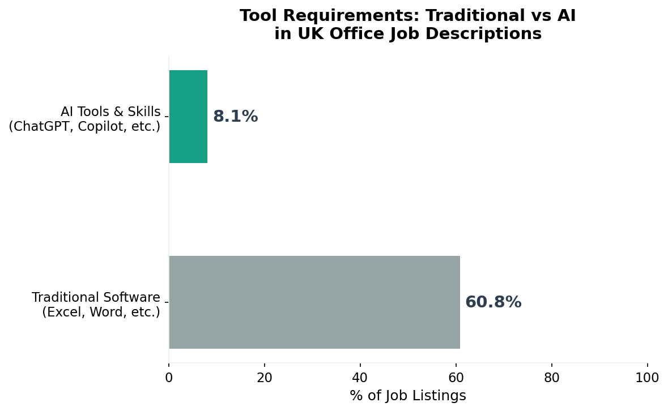

8. Methodology

Data Collection
- Source: LinkedIn public job listings, United Kingdom
- Collection period: March 2026
- Collection method: Apify LinkedIn Jobs Scraper (curious_coder/linkedin-jobs-scraper) via Apify API
- Total unique listings after deduplication: 1,019
- Deduplication: By LinkedIn job ID

Search Scope
Searches targeted non-technical office and administrative roles across the UK. Over 100 distinct search queries were used, covering: finance assistants, payroll administrators, credit controllers, sales coordinators, customer service advisors, HR coordinators, office managers, marketing coordinators, procurement assistants, compliance officers, legal assistants, project administrators, receptionists, data entry clerks, events coordinators, and similar roles. The aim was a broad cross-section of everyday office work rather than specialist technology positions.

AI Detection Method
Each job description was scanned for two categories of terms:
- Named AI tools and platforms (e.g., ChatGPT, Copilot, Claude, Gemini, Midjourney, etc.) — 34 terms
- AI-related terminology (e.g., artificial intelligence, machine learning, generative AI, prompt engineering, AI tools, etc.) — 31 terms
All matching used word-boundary regular expressions to prevent partial matches (e.g., “word” does not match inside “keyword”). The term “bard” was excluded due to false positive matching with “Lombard,” and standalone “prompting” was excluded as it commonly appears in non-AI contexts (e.g., “prompting clients”).

AI Requirement Classification
Jobs referencing AI were further classified by proximity of the AI term to requirement language:
- Required: AI term appears within 200 characters of words like “required,” “essential,” “must have,” “mandatory”
- Preferred: AI term appears within 200 characters of words like “preferred,” “desirable,” “advantage,” “beneficial”
- Mentioned: AI term appears in the description but not near requirement/preference language

Role Classification
Jobs were categorised by title keywords into: Finance & Accounting, Sales & Business Dev, HR & Recruitment, Marketing, Office & Admin, Customer Service, Legal & Procurement, and Project & Operations. Jobs not matching any category were placed in “Other.”

Limitations
- LinkedIn public search returns a limited number of results per query. The sample is not a random probability sample of all UK job listings.
- The study captures only explicit mentions of AI in job descriptions. Employers may expect or value AI skills without stating them.
- Some job descriptions may mention AI in the context of the employer’s product rather than as a skill required of the applicant.
- The “Other” category (549 jobs) is larger than the named categories because many job titles do not map cleanly to the predefined classification keywords.
- Seniority levels are as assigned by LinkedIn and may not perfectly reflect actual role seniority.

9. Accompanying Data Files
- UK_AI_Jobs_Study_Raw_Data_March_2026.xlsx — Full dataset of all 1,019 job listings with analysis flags, AI/traditional tool matches, and original descriptions. AI-positive rows are highlighted green.
- raw_data.json — Original scraped data in JSON format.
- analyzed_jobs.csv — Analysis results in CSV format.
- summary_stats.json — Aggregated statistics used to generate this document.

